Recruitment Pack

**Children and Young People’s Schools Coordinator**

August 2025

**Thank you for your interest in working with Lancashire Mind**

**Who are we?**

Lancashire Mind is an independent mental health charity, delivering our impactful strategy that has been co-created with the people of Lancashire. We reach over 10,000 people each year.

We’re an active member of the national Mind Federation, linking us with over 100 other local Mind organisations across England and Wales, providing excellent opportunities for good practice sharing and partnership working.

Our purpose is to support people in Lancashire to achieve the best mental health and wellbeing possible.

To achieve this, we:

**Connect Minds** through ongoing engagement and co-creation.

**Change Minds** by challenging stigma and increasing knowledge around mental health.

**Support Minds** by being a source of help, where, when, and how people need it.

We value being:

**Real**

Grounded in lived experience and making sure our work is relevant to Lancashire.

**Bold**

We’re not afraid to demand better for people who need our help.

**Caring**

Treating people with compassion and respect and being there for people and communities in Lancashire.

**Open**

Working inclusively to tackle issues and being open to new ideas.

We believe that everyone can achieve good mental health and wellbeing, and that resilience is the key to sustaining it. With 50% of mental health conditions developing before the age of 14, building resilience from an early age is central to the work we do.

We empower people in Lancashire to value and take care of their mental health. Our work ranges from 1:1 support for people facing multiple and complex barriers, to preventative and influencing work. We work in partnership with others to make mental wellbeing a priority.

We are determined to be an organisation that is representative of the diversity of the whole county and one that challenges the mental health inequalities faced by our communities. We’re working to become a truly anti-racist organisation.

Everyone who works for Lancashire Mind is fuelled by a passionate belief that enabling people to achieve mental wellbeing will reduce the number of people who go on to develop a mental health condition, and for those who do, to have a better chance of remaining well.

**Join us to connect, change and support minds in Lancashire.**

**Why work with us?**

As well as striving to meet the mental health needs of our local communities, we aim to be a good employer and do what we can to provide a supportive and healthy environment for our employees.

You’ll get a friendly welcome from colleagues and clear expectations about your role and how it contributes to achieving Lancashire Mind's goals.

**Flexible working**

We operate a hybrid working policy. For office-based roles, you can split your time between home and our office in Chorley. For service delivery roles, you'll also spend time working in communities at a range of different venues. Depending on the requirements of the role, we will also consider remote working.

Our full-time hours are 35 hours per week. We are open to requests for flexible working hours, including compressed hours. Everyone is provided with the equipment needed to work from home or in the community.

**Leave**

Full-time staff have 25 days annual leave, plus bank holidays (pro rata for part-time roles). We close for the days between Christmas and New Year, which are given as additional leave entitlement (pro rata).

We’ve recently introduced long-service leave. Employees who’ve worked for Lancashire Mind continuously for 3 years are entitled to an extra day's holiday for each full year of service, up to a maximum of 5 days (pro rata). We’ve also introduced a buying/selling annual leave scheme.

We offer five paid days of emergency/compassionate leave (pro rata) to help you manage unexpected life events.

**Wellbeing benefits**

We have a workplace wellbeing scheme provided by a small team of staff champions. Champions organise wellbeing activities and run a regular wellbeing survey, giving staff the chance to input to improving wellbeing in the workplace.

We offer an annual, paid wellbeing half-day to encourage all employees to do something positive for their own wellbeing.

Our Employee Assistance Programme gives you and your immediate family access to a 24/7, 365 confidential helpline, GP advice line and prescription service.

We cover the cost of an annual standard eye test and annual flu vaccination for all staff, regardless of your role.

**Financial benefits**

We offer the opportunity for staff to save for their retirement by providing a workplace pension scheme, with options for matched contributions up to 6%.

From your start date you'll be eligible for the company sick pay scheme, which increases with each year served up to 6 weeks full pay, 6 weeks half pay after five years of service.

**Learning and development**

You’ll have protected time during regular supervision sessions with your line manager to reflect on and plan the work you do. We provide a wide range of learning opportunities, including shadowing other staff, as well as regular training courses.

**Who you’ll work with**

Our work with children and young people aims to support them to achieve improved confidence, resilience and to develop positive coping strategies to improve and maintain mental wellbeing.

There is a huge need for mental health support for children and young people:

*One in six children aged five to 16 were identified as having a probable mental health problem in July 2021, a huge increase from one in nine in 2017.*

*That’s five children in every classroom.*

We work with children from the age of 5 up to young adults in schools and in the community across a number of projects. Support can be delivered in groups, one to one and both face to face and virtually.

Lancashire Mind is successful in delivering a whole school approach programme on resilience and prevention called Resilient Minds. This is funded by the NHS Lancashire and South Cumbria Integrated Care Board. We also deliver on a range of school projects.

We are working in several areas of Lancashire in primary, secondary schools and colleges. We will be offering a range of support to young people, school staff and parents to improve mental health and wellbeing across the setting.

**Your role**

This is an exciting opportunity to be part of projects embedding early intervention and resilience building in schools and colleges.

As a CYP Schools Coordinator, you will be delivering a range of support to children and young people. As such, you will be a confident practitioner with experience of working with young people aged 5 to 18, ideally in a school setting.

You will deliver group support to children and young people which will include but not limited to:

* Five Ways to Wellbeing assembly
* Bounce Forward – our universal resilience building programme over a series of 6 weeks
* Wellbeing Ambassador training
* Topic based workshops on topics such as sleep, exam stress, managing anxiety, self-esteem

In addition, you will deliver an introduction to resilience workshops to parents and school staff.

You will have excellent communication skills. You will be confident and personable to enable you to build and maintain a positive relationship with schools. You will be warm and engaging with the ability to get the best out of group work with young people.

You will have a good understanding of mental health, wellbeing and resilience; with the ability to translate these topics into fun, engaging sessions. You will be adept at storytelling; demonstrating the impact that our services have.

Essential to the role are excellent organisational and administrative skills. As you will be predominantly based remotely, you will be autonomous, self-motivated with the ability to manage your own workload effectively.

**Above all, we want someone who believes in our vision of a Lancashire where everyone has the opportunity to have the best mental health and wellbeing** possible.

**Job description**

**Job title:** CYP Schools Coordinator

**Hours:** 3 and a half days (24.5 hours)

**Contract:** Fixed-term until 31 August 2026

**Salary:** £25,850

**Responsible to:** CYP Schools Lead

**Location:** Contractual base is our head office. Delivery will take place in schools across Lancashire.

**Overview**

In this exciting and challenging role, you will be responsible for developing, delivering and evaluating interventions in schools and colleges across Lancashire. Services will focus on building resilience and increasing understanding of mental health and wellbeing at an early stage. You will deliver a range of services to children and young people, parents and school staff in group settings.

You will liaise with school staff in schools and colleges in your designated area, organising and agreeing the schedule of delivery. You will then prepare and deliver sessions and complete associated administration and data collection for reporting and impact measurement purposes.

**Main duties and responsibilities**

* Plan, deliver and evaluate a range of resilience and early intervention support in schools and colleges across Lancashire
* Deliver assemblies, Bounce Forward resilience programme, wellbeing workshops, wellbeing ambassador training to groups of children and young people
* Deliver resilience building workshops to parents and school staff
* Build and maintain effective relationships with schools, colleges and other stakeholders across the county to deliver effective services
* Capture and analyse quantitative and qualitative data, including stories from a range of people accessing the service to demonstrate impact
* Understand and implement best practice with regards to children and young people’s safeguarding. Follow all internal and external safeguarding procedures to keep children safe
* Complete all required project administration to a high standard and in a timely and efficient way
* Provide supportive and motivating guidance to project volunteers
* Understand and implement Lancashire Mind’s policies and procedures, including key policies such as lone working, health and safety and information governance
* Work with colleagues to identify opportunities to develop this area of work and support colleagues to write funding bids
* Attend internal and external meetings and training, as and when necessary
* Undertake flexible working hours in line with the requirements of the role (where possible, working hours don’t go above the contracted hours but this is sometimes unavoidable so we operate a time off in lieu (TOIL) policy, this allows any time owed to be taken back at a later date)
* Travel across Lancashire as required and attend face to face team meetings in the office or an alternative location (travel expenses reimbursed, except for usual commute to and from work)
* Undertake other duties, as and when deemed necessary by a Senior Manager.

**Please note:** Lancashire Mind follows Safer Recruitment practices and have a commitment to safeguarding people who use our services. Therefore, this role is subject to an enhanced Disclosure and Barring Service (DBS) check so all applicants must be willing to undergo the check. If invited to interview, we will ask you to provide evidence of your qualifications and right to work in the UK.

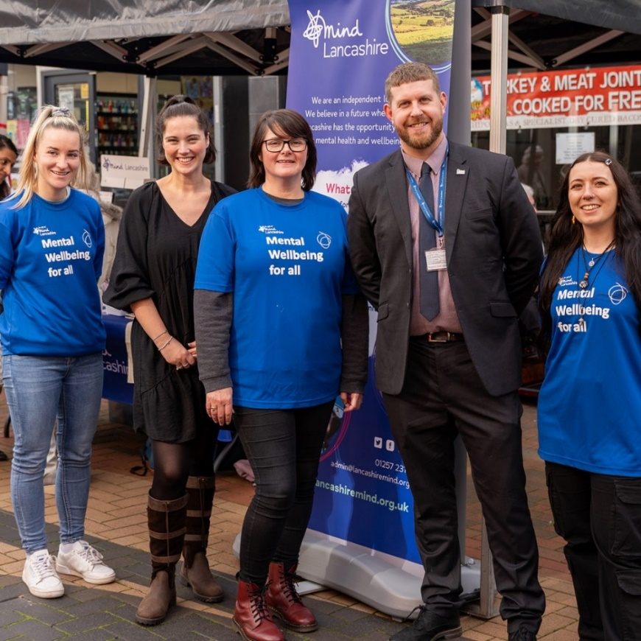**Person specification**

We only consider inviting to interview people who show that they possess the required experience, skills and personal attributes, as outlined in the table below. **When completing your application form, please use examples from your professional and personal life to illustrate how you fulfil all the criteria to be assessed at application stage only (A).**

Lancashire Mind is committed to fighting racism and other forms of oppression. We want to be a great employer for all our staff, regardless of their background or characteristics. We recognise that not everyone is the same and that different people will require different support to fulfil their potential. We want to ensure Lancashire becomes a place of greater equity and inclusion. One thing we can do to work towards that goal is to ensure that our staff team is representative of the diverse communities across Lancashire, and particularly those communities we know face mental health inequalities. We particularly encourage applications from those communities and from anyone with experience of living with a mental health condition.

|  |  |  |
| --- | --- | --- |
|  | **Criteria** | **Assessed at application (A) or interview (I)** |
| **Qualifications and/or work experience** | 1. Relevant work experience in a similar role, preferably in schools and/or the charity sector | A |
| **Knowledge and experience** | 1. Experience of delivering projects with children/young people in groups, ideally in schools | A and I |
| 1. Understanding of how schools and colleges operate | A |
| 1. Knowledge and understanding of mental health and the barriers that young people face to achieving mental wellbeing | A and I |
| 1. Engaging and working in partnership with a diverse range of stakeholders | A |
| 1. Understanding of safeguarding, professional boundaries, confidentiality and data protection; particularly in relation to children | A and I |
| 1. Experience of monitoring and evaluation and demonstrating impact through storytelling | I |
| **Skills, abilities and competencies** | 1. Excellent communication skills with the ability to deliver effectively in group settings | A and I |
| 1. Skilled in building and maintaining relationships with a wide range of stakeholders eg, schools, colleges, families and community organisations | A and I |
| 1. Ability to manage conflicting demands and pressures and work autonomously | A and I |
| 1. Excellent organisation and administrative skills with the ability to maintain accurate records | I |
| 1. Excellent office IT skills (Microsoft Office 365, including Excel) and the ability to learn new software packages, including video conferencing platforms | A |
| **Personal attributes** | 1. Positive, enthusiastic and friendly attitude | I |
| 1. Resilient and committed to promoting mental wellbeing for all | A |
| 1. A demonstrable personal commitment to equal, diversity and inclusion; and challenging discrimination | I |

**To apply**

If you would like to discuss the job before applying please contact Charlotte Sutton, CYP School Lead: [charlottesutton@lancashiremind.org.uk](mailto:charlottesutton@lancashiremind.org.uk)

Applications must be submitted using a Lancashire Mind job application form, which can be downloaded from our website [www.lancashiremind.org.uk/recruitment](http://www.lancashiremind.org.uk/recruitment) or requested by emailing [recruitment@lancashiremind.org.uk](mailto:recruitment@lancashiremind.org.uk)

**The deadline for applications is 9am on Friday 29th August 2025**

Email your completed application form to [recruitment@lancashiremind.org.uk](mailto:recruitment@lancashiremind.org.uk). Please do not convert your form to a PDF, otherwise it will not be possible for us to remove the identifying information before sending your application to the recruitment panel.

Late applications will not be accepted. Those who do not adequately demonstrate how they fulfil the criteria required at application stage, will not be considered for shortlisting.

**Interviews for this post are scheduled to take place on Tuesday 16th September so please keep this date free.** Successful candidates will be notified no later than Tuesday 10th September. Interviews will be held in-person at a venue to be confirmed.

If you have not heard from us by two weeks after the deadline, please assume that you have not been shortlisted on this occasion. The organisation regrets that it cannot provide feedback to unsuccessful applicants at the shortlisting stage.

If you have any questions about the application process or require support with the process, please contact our Operations Team on 01257 231660.

**What to expect at interview**

Shortlisted applicants will be invited to attend an interview, which will usually take place at the Lancashire Mind office in Chorley. Occasionally, they are held at other venues in Lancashire or virtually via Microsoft Teams. Details of the venue and times will be included within the email invite. You can expect the following if you are attending an interview:

* All interviews include a set of questions asked by a panel of three people.
* Some interviews include a presentation, which will need to be prepared in advance of the interview. Where a presentation is required, we provide a minimum of 5 days’ notice to allow time for preparation. We recommend applicants pencil time into their diary for preparing a presentation, in the event they are shortlisted.
* We allow 30 minutes for candidates to read the panel questions and make notes, which can be referred to during the interview.
* The panel interview will usually consist of between 6 and 8 questions and takes around 30 to 45 minutes.
* We aim to support people to feel as comfortable as possible at interview and are happy for you to ask for clarification on any of the questions asked by the panel, as well as taking a few moments to think about a question before answering.
* Once the panel have asked their questions, candidates can ask questions about the job and/or Lancashire Mind.
* **A pink lines on a black background

  Description automatically generated**A picture containing plant

  Description automatically generatedWe can adapt the interview process for individuals where required. There is space on the job application form to request reasonable adjustments.

**Lancashire Mind**

80-82 Devonshire Road

Chorley

Lancashire

PR7 2DR

01257 231660

admin@lancashiremind.org.uk

www.lancashiremind.org.uk

Registered Charity Number 1081427

Registered Company Number 3888655