Recruitment Pack

**Children and Young People’s Wellbeing Coach**

August 2025

**Thank you for your interest in working with Lancashire Mind**

**Who are we?**

Lancashire Mind is an independent mental health charity, delivering our impactful strategy that has been co-created with the people of Lancashire. We reach over 10,000 people each year.

We’re an active member of the national Mind Federation, linking us with over 100 other local Mind organisations across England and Wales, providing excellent opportunities for good practice sharing and partnership working.

Our purpose is to support people in Lancashire to achieve the best mental health and wellbeing possible.

To achieve this, we:

**Connect Minds** through ongoing engagement and co-creation.

**Change Minds** by challenging stigma and increasing knowledge around mental health.

**Support Minds** by being a source of help, where, when, and how people need it.

We value being:

**Real**

Grounded in lived experience and making sure our work is relevant to Lancashire.

**Bold**

We’re not afraid to demand better for people who need our help.

**Caring**

Treating people with compassion and respect and being there for people and communities in Lancashire.

**Open**

Working inclusively to tackle issues and being open to new ideas.

We believe that everyone can achieve good mental health and wellbeing, and that resilience is the key to sustaining it. With 50% of mental health conditions developing before the age of 14, building resilience from an early age is central to the work we do.

We empower people in Lancashire to value and take care of their mental health. Our work ranges from 1:1 support for people facing multiple and complex barriers, to preventative and influencing work. We work in partnership with others to make mental wellbeing a priority.

We are determined to be an organisation that is representative of the diversity of the whole county and one that challenges the mental health inequalities faced by our communities. We’re working to become a truly anti-racist organisation.

Everyone who works for Lancashire Mind is fuelled by a passionate belief that enabling people to achieve mental wellbeing will reduce the number of people who go on to develop a mental health condition, and for those who do, to have a better chance of remaining well.

**Join us to connect, change and support minds in Lancashire.**

**Why work with us?**

As well as striving to meet the mental health needs of our local communities, we aim to be a good employer and do what we can to provide a supportive and healthy environment for our employees.

You’ll get a friendly welcome from colleagues and clear expectations about your role and how it contributes to achieving Lancashire Mind's goals.

**Flexible working**

We operate a hybrid working policy. For office-based roles, you can split your time between home and our office in Chorley. For service delivery roles, you'll also spend time working in communities at a range of different venues. Depending on the requirements of the role, we will also consider remote working.

Our full-time hours are 35 hours per week. We are open to requests for flexible working hours, including compressed hours. Everyone is provided with the equipment needed to work from home or in the community.

**Leave**

Full-time staff have 25 days annual leave, plus bank holidays (pro rata for part-time roles). We close for the days between Christmas and New Year, which are given as additional leave entitlement (pro rata).

We’ve recently introduced long-service leave. Employees who’ve worked for Lancashire Mind continuously for 3 years are entitled to an extra day's holiday for each full year of service, up to a maximum of 5 days (pro rata). We’ve also introduced a buying/selling annual leave scheme.

We offer five paid days of emergency/compassionate leave (pro rata) to help you manage unexpected life events.

**Wellbeing benefits**

We have a workplace wellbeing scheme provided by a small team of staff champions. Champions organise wellbeing activities and run a regular wellbeing survey, giving staff the chance to input to improving wellbeing in the workplace.

We offer an annual, paid wellbeing half-day to encourage all employees to do something positive for their own wellbeing.

Our Employee Assistance Programme gives you and your immediate family access to a 24/7, 365 confidential helpline, GP advice line and prescription service.

We cover the cost of an annual standard eye test and annual flu vaccination for all staff, regardless of your role.

**Financial benefits**

We offer the opportunity for staff to save for their retirement by providing a workplace pension scheme, with options for matched contributions up to 6%.

From your start date you'll be eligible for the company sick pay scheme, which increases with each year served up to 6 weeks full pay, 6 weeks half pay after five years of service.

**Learning and development**

You’ll have protected time during regular supervision sessions with your line manager to reflect on and plan the work you do. We provide a wide range of learning opportunities, including shadowing other staff, as well as regular training courses.

**Who you’ll work with**

Lancashire Mind has a comprehensive wellbeing coaching service for both adults and children and young people from the age of 10. Support is delivered both virtually and face to face in the community.

Wellbeing Coaching is a tier 2 / secondary prevention service which delivers one-to-one and small group support sessions. Wellbeing coaches work with people at risk of developing a mental health condition to enable them to develop positive coping strategies and take action to improve their wellbeing.

Wellbeing Coaching can have excellent results supporting people experiencing anxiety, low mood, low confidence, stress and issues with sleep.

Coaches deliver one-to-one and group sessions, delivering low intensity interventions to help people build resilience, develop healthy coping strategies, and improve their wellbeing and quality of life.

Coaching is grounded in cognitive behavioural therapy techniques. Sessions involve guided self-help and behavioural activation; utilising techniques such as goal setting, thought challenging, diary planning, relaxation and breathing techniques.

**Your role**

As a CYP Wellbeing Coach you will deliver coaching on several projects as part of our Wellbeing Coach service. Support could be virtual or face to face. As such, you will be a confident practitioner with experience of working with young people and be able to work flexibly and autonomously.

You will assess suitability for wellbeing coaching and then provide up to 6 one-hour sessions per client. You will have an excellent understanding of mental health and have experience of providing mental health support on a 1:1 basis.

You will be responsible for effectively managing a caseload of clients, keeping accurate records and providing output and outcome data to demonstrate the impact of the service. Therefore, administration and organisational skills are important.

You will be a team player and work closely with colleagues to promote the service and be responsible for generating referrals. You will develop and build relationships to enable you to work in partnership with agencies across Lancashire.

To succeed in the role, you will need excellent communication skills, be warm and engaging with the ability to put clients at ease. You will be calm, focussed and resilient.

This is a fantastic opportunity to be part of a growing service and a friendly and supportive team.

e.**

**Job description**

**Job title:** Wellbeing Coach (Children and Young People)

**Hours:** Minimum of 32 hours per week with the possibility of up to 35 hours for the right candidate

**Contract:** Fixed-term until 31 March 2026, with the possibility of extension if funding permits

**Salary:** £25,850 (pro rata)

**Responsible to:** CYP Coaching Lead

**Location:** Contractual base is our Head Office. Delivery will take place both from home and in the community

**Overview**

Wellbeing Coaches deliver one to one and small group sessions, delivering low intensity interventions to help people build resilience, develop healthy coping strategies, and improve their wellbeing and quality of life. This post will work on several projects within our Wellbeing Coaching service, specifically working with children and young people.

The coach will deliver predominantly 1:1 support over 6 x 1 hour coaching sessions and support people with challenges such as anxiety, low mood, low self-esteem, loss and change. The Wellbeing Coach is responsible for managing their own caseload, completing accurate paperwork, managing data to demonstrate the impact of the service. They will develop and maintain relationships with other agencies, working in partnership to support service users. They will work closely with the CYP Coaching Lead to review and develop our approach to ensure we are providing the best service possible across Lancashire.

**Main duties and responsibilities**

* Manage a caseload of 1:1 coaching clients and small group coaching sessions to enable children and young people to overcome barriers to mental wellbeing
* Utilise techniques such as goal setting, thought challenging, diary planning, relaxation and breathing techniques as part of coaching sessions
* Undertake assessments determining the suitability of the referrals and the level of support most suitable for them
* Complete all required assessment, referral and evaluation administration to a high standard and in a timely and efficient way
* Actively promote Lancashire Mind’s Wellbeing Coaching service to generate referrals and meet quarterly project targets
* Build and maintain strong and active relationships with project partners and stakeholders to develop and maintain referral pathways
* Understand and implement key policies and procedures, such as safeguarding and GDPR compliance
* Capture and analyse quantitative and qualitative data, including feedback from service users, to feed into monitoring reports and project evaluation
* Work with colleagues to identify opportunities to develop this area of work and support colleagues to write funding bids
* Be an ambassador for Lancashire Mind, promoting our range of services and supporting our fundraising efforts e.g. volunteering at events such as Mental Elf and World Mental Health Day
* Understand and implement Lancashire Mind’s policies and procedures, including key policies such as safeguarding, lone working and information governance.
* Attend internal and external meetings and training, as and when necessary.
* Undertake flexible working hours including evening and weekends (where possible, working hours don’t go above the contracted hours but this is sometimes unavoidable, so we operate a time off in lieu (TOIL) policy, this allows any time owed to be taken back at a later date).
* Travel across Lancashire as required and attend face to face team meetings in the office or an alternative location (travel expenses reimbursed, except for usual commute to and from work).
* Undertake other duties, as and when deemed necessary by a Senior Manager.

**Please note:** Lancashire Mind follows Safer Recruitment practices and have a commitment to safeguarding people who use our services. Therefore, this role is subject to an enhanced Disclosure and Barring Service (DBS) check so all applicants must be willing to undergo the check. If invited to interview, we will ask you to provide evidence of your qualifications and right to work in the UK.

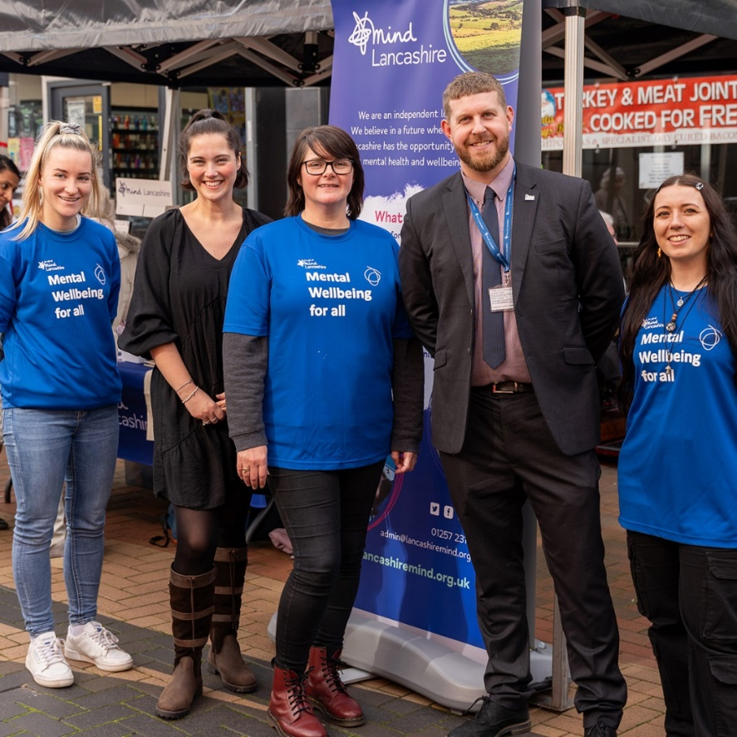**Person specification**

We only consider inviting to interview people who show that they possess the required experience, skills and personal attributes, as outlined in the table below. **When completing your application form, please use examples from your professional and personal life to illustrate how you fulfil all the criteria to be assessed at application stage only (A).**

Lancashire Mind is committed to fighting racism and other forms of oppression. We want to be a great employer for all our staff, regardless of their background or characteristics. We recognise that not everyone is the same and that different people will require different support to fulfil their potential. We want to ensure Lancashire becomes a place of greater equity and inclusion. One thing we can do to work towards that goal is to ensure that our staff team is representative of the diverse communities across Lancashire, and particularly those communities we know face mental health inequalities. We particularly encourage applications from those communities and from anyone with experience of living with a mental health condition.

|  |  |  |
| --- | --- | --- |
|  | **Criteria** | **Assessed at application (A) or interview (I)** |
| **Qualifications and/or work experience** | 1. Relevant work experience in a similar role, preferably in the voluntary or community sector | A |
| **Knowledge and experience**  **Skills, abilities and competencies** | 1. Experience of supporting children and young people both one to one and in groups with their mental health | A |
| 1. Knowledge of mental health and the barriers young people face to achieve good wellbeing | A and I |
| 1. Experience of coaching young people and using techniques such as guided self-help, thought challenging and goal setting | A and I |
| 1. Experience of successfully engaging and working with a wide range of stakeholders to deliver project outcomes | A and I |
| 1. Knowledge and understanding of professional boundaries, safeguarding and data protection policies and procedures | A and I |
| 1. Experience of monitoring and evaluation and demonstrating impact | A |
| 1. Ability to communicate effectively with a wide range of people and through a variety of methods | A and I |
| 1. Ability to work independently and adapt to changing or unexpected circumstances | A and I |
| 1. Ability to motivate and inspire others, including colleagues and people who use Lancashire Mind services | I |
| 1. Excellent numeracy, literacy and report writing skills with the ability to maintain accurate records | A |
| 1. Excellent office IT skills (Microsoft Office 365, including Excel), with the ability to use video conferencing platforms and learn new software packages | A |
|  | 1. Ability to handle multiple tasks in a fast-paced environment, set priorities for yourself and in collaboration with colleagues | I |
| **Personal attributes** | 1. Resilient and committed to promoting mental wellbeing for all | A |
| 1. A demonstrable personal commitment to equal, diversity and inclusion; and challenging discrimination | I |
| 1. Positive, enthusiastic and friendly attitude | I |

**To apply**

If you would like to discuss the job before applying, contact Hazel Cook, Children and Young People’s Coaching Lead, [hazelcook@lancashiremind.org.uk](mailto:hazelcook@lancashiremind.org.uk)

Applications must be submitted using a Lancashire Mind job application form, which can be downloaded from our website [www.lancashiremind.org.uk/recruitment](http://www.lancashiremind.org.uk/recruitment) or requested by emailing [recruitment@lancashiremind.org.uk](mailto:recruitment@lancashiremind.org.uk).

**The deadline for applications is 9am on Friday 12th September 2025**

Email your completed application form to [recruitment@lancashiremind.org.uk](mailto:recruitment@lancashiremind.org.uk). Please do not convert your form to a PDF, otherwise it will not be possible for us to remove the identifying information before sending your application to the recruitment panel.

Late applications will not be accepted. Those who do not adequately demonstrate how they fulfil the criteria required at application stage, will not be considered for shortlisting.

**Interviews for this post are scheduled to take place on Wednesday 24th September so please keep this date free as alternatives can’t be offered.** Successful candidates will be notified no later than 17th September. Interviews will be held in-person, venue to be confirmed nearer the time.

If you have not heard from us by two weeks after the deadline, please assume that you have not been shortlisted on this occasion. The organisation regrets that it cannot provide feedback to unsuccessful applicants at the shortlisting stage.

If you have any questions about the application process or require support with the process, please contact our Operations Team on 01257 231660.

**What to expect at interview**

Shortlisted applicants will be invited to attend an interview, which will usually take place at the Lancashire Mind office in Chorley. Occasionally, they are held at other venues in Lancashire or virtually via Microsoft Teams. Details of the venue and times will be included within the email invite. You can expect the following if you are attending an interview:

* All interviews include a task and set of questions asked by a panel of three people.
* Some interviews include a presentation, which will need to be prepared in advance of the interview. Where a presentation is required, we provide a minimum of 5 days’ notice to allow time for preparation. We recommend applicants pencil time into their diary for preparing a presentation, in the event they are shortlisted.
* We allow 30 minutes for candidates to read the panel questions and make notes, which can be referred to during the interview.
* The panel interview will usually consist of between 6 and 8 questions and takes around 30 to 45 minutes.
* We aim to support people to feel as comfortable as possible at interview and are happy for you to ask for clarification on any of the questions asked by the panel, as well as taking a few moments to think about a question before answering.
* Once the panel have asked their questions, candidates can ask questions about the job and/or Lancashire Mind.
* **A pink lines on a black background

  Description automatically generated**A picture containing plant

  Description automatically generatedWe can adapt the interview process for individuals where required. There is space on the job application form to request reasonable adjustments.

**Lancashire Mind**

80-82 Devonshire Road

Chorley

Lancashire

PR7 2DR

01257 231660

admin@lancashiremind.org.uk

www.lancashiremind.org.uk

Registered Charity Number 1081427

Registered Company Number 3888655