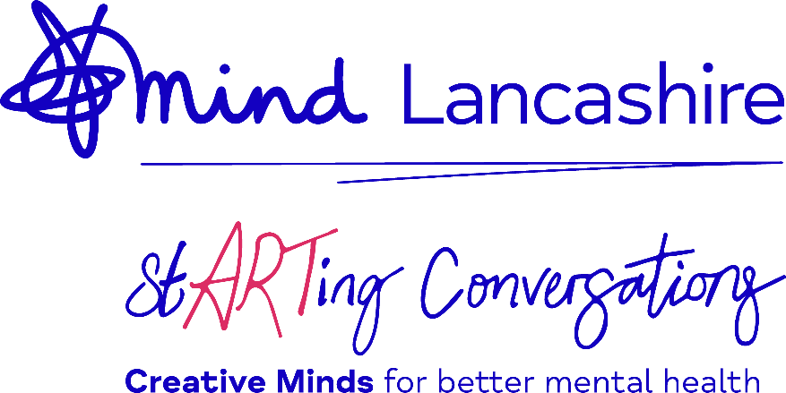

If my mind could speak…
What would your mental health say if it had a voice?
Lancashire Mind invites you to explore how art, music, poetry, photography and storytelling can help us understand and share our mental health experiences.
Whether you’re a school, workplace, community group or individual – we want everyone across Lancashire to join us and share their creative ideas!

Your Details
Please provide a title for your submission*:

Name (or pseudonym) as you want it

to appear alongside your submission*:

Email address we can use to contact you

about your submission or exhibition*:

Can you share 3 emotions you felt when

you created your submission:

Submission type (artwork, music, video,

photograph, poem etc)

Please tick the box that applies to you.

Individual submission School Workplace/Organisation

Community Group/Hub Lancashire Mind Volunteer Other

Summary of your submission, including any key themes or messages, inspirations or explanations.

Consent & Submission
Thank you for sharing your creativity with Lancashire Mind as part of our stARTing conversations project. By submitting your creative work (including artwork, writing, photography, music or any other medium), you confirm that:

- You are the original creator of the work and have the right to share it.

- You give full permission for Lancashire Mind to use your submission:
- As part of the stARTing conversations campaign
- In both digital and print formats
- On Lancashire Mind’s website, social media, newsletters, and promotional materials
- In internal communications and fundraising materials
- For future mental health awareness campaigns or events

- Your name and age group (if applicable) may be included with your submission unless you choose to remain anonymous.

- If submitting on behalf of a child or young person under 16, you confirm that you are their parent, carer, or teacher and have the authority to give consent on their behalf.

I, (full name of person giving consent), agree to the above terms and give Lancashire Mind permission to use my submitted work for promotional, awareness and organisational purposes.

Please tick the box to confirm your agreement
_
You can ask, in writing, for Lancashire Mind to stop using your submission at any time, by emailing admin@lancashiremind.org.uk. The revoking of consent will not affect any actions taken before the written notification. Your submission will not be used in future marketing materials but may continue to appear were already in circulation, and will be stored in a secure location, kept as long as they are relevant and after that time destroyed or archived.

Full Name:

Signature: Date:

I am a parent/carer/guardian or teacher (ignore if not relevant)

Yes:

Privacy Policy
Lancashire Mind are committed to protecting your personal information in accordance with all applicable laws concerning the protection of personal data. We will only collect relevant personal data from you to provide you with services, improve what we do and to help more people.
Where we collect equality, diversity and inclusion data, known as special category data, this is anonymised and may be shared with funders or agencies to help us carry out our work as a charity.
We will never share your personal data with a third party without your explicit consent, unless lawfully obliged to do so, or where there is serious risk of harm.
We store your data securely and confidentially and only store it for as long as we need to. For full details please see our Privacy Policy on our website (lancashiremind.org.uk/lancashire-mind-policies/privacy-policy). If you are unhappy with how we have handled your personal data, we have a complaints procedure, full details are on our website (lancashiremind.org.uk). On request, a copy of the complaints leaflet can be either posted or emailed to you.

I confirm my consent for Lancashire Mind to collect my data in line with the Privacy Policy.

Yes: I confirm my consent

I would like to receive updates about Lancashire Mind’s events, services and activities

Yes: No:

Where to return this form
Please email this form along with a digital copy of your submission (as a jpg, PDF, video, mp3 or other accessible format) to the following email address:

marketingevents@lancashiremind.org.uk
using the subject line: Creative Minds project

If your submission is above 5MB please use the free version of WeTransfer | Send Large Files Fast using the same email and subject line as above.

Thank you!

